**HORMISDALLEN SCHOOL - KYEBANDO**

**PRE-PLE SET 1 EXAMINATION, 2023**

**PRIMARY SEVEN SOCIAL STUDIES**

Duration: 2 Hours 15 Minutes

**NAME: ______________________________________________ STREAM: ___________**

EMIS NO.

INDEX NO.

**SECTION A**

1. Which animal is commonly used for transport in the Sahara desert?

____________________________________________________________________

1. State any one challenge faced by the government while collecting taxes.

____________________________________________________________________

1. Give any one characteristic of equatorial climate.

____________________________________________________________________

1. Name any one example of a service industry in Uganda.

____________________________________________________________________

1. What is meant by the term equinox?

____________________________________________________________________

1. State any one way electricity promotes economic development in an area.

____________________________________________________________________

1. Why is the item below important on a school compound?

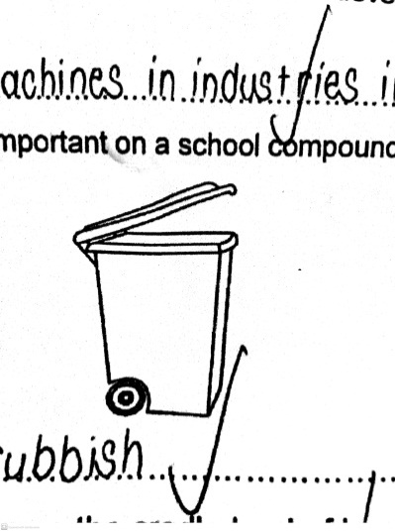

____________________________________________________________________

1. Why is East Africa known as the cradle land of human race?

____________________________________________________________________

1. Give any one economic importance of Fort Jesus to Kenya.

____________________________________________________________________

1. Name any one tribe in Uganda that belongs to the Plain Nilotes.

____________________________________________________________________

1. Which nationalist chaired the 1958 Pan African Conference in Ghana?

____________________________________________________________________

1. How is Blue Nile useful to the Gezira irrigation scheme in Sudan?

____________________________________________________________________

1. Name the economic activity illustrated below.

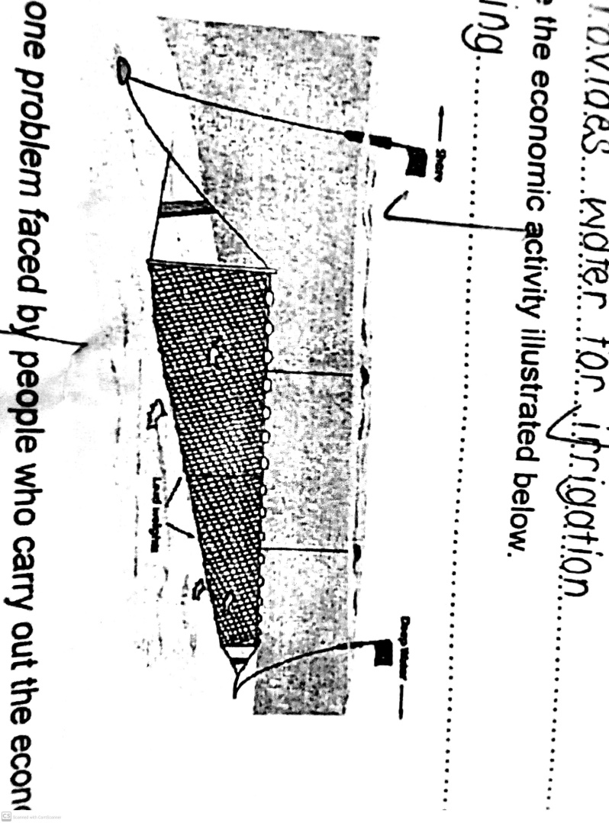

____________________________________________________________________

1. Give any one problem faced by the people who carry out the economic activity illustrated below.

____________________________________________________________________

1. In which year did Uganda get her independence?

____________________________________________________________________

1. Name the type of forest where trees grow by themselves.

____________________________________________________________________

1. State any one cause of the Great Trek in South Africa.

____________________________________________________________________

1. Name the symbol of Uganda as a nation shown below.

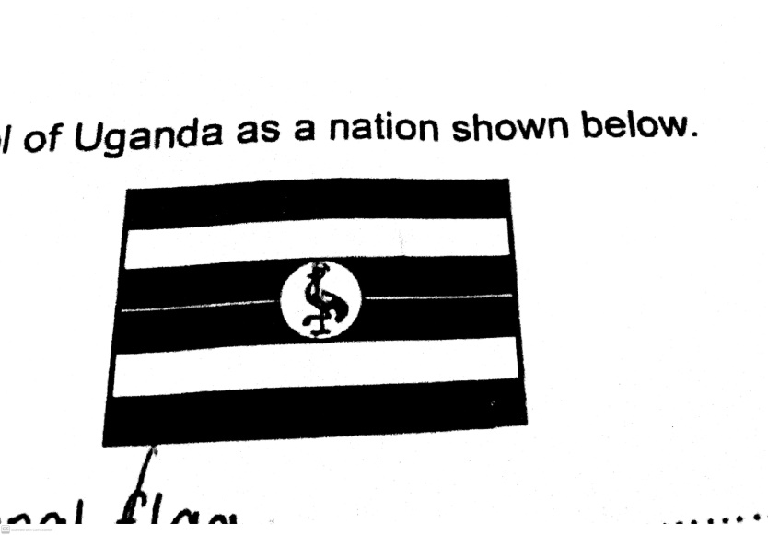

____________________________________________________________________

1. Give any one cause of the 1907 Nyangire rebellion in Bunyoro Kingdom.

____________________________________________________________________

1. How is River Niger important to the economy of Nigeria?

____________________________________________________________________

1. What do you understand by the term surplus budget?

____________________________________________________________________

1. How is a forest useful to the carpentry industry?

____________________________________________________________________

1. State any one effect of industrialization to the environment.

____________________________________________________________________

1. Give one advantage of having a nuclear family.

____________________________________________________________________

1. Name any one tribe in Uganda that practices nomadic pastoralism.

____________________________________________________________________

1. Why do trees in Savanna region shed their leaves?

____________________________________________________________________

**Study the diagram below and use it to answer question 27.**

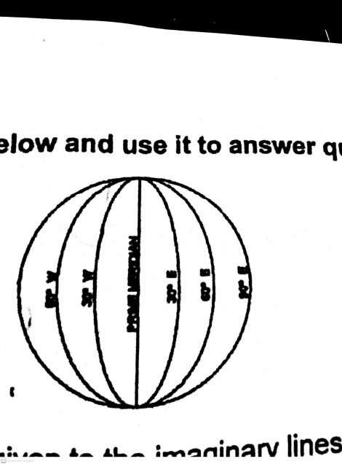

1. What general name is given to the imaginary lines in the diagram above?

____________________________________________________________________

1. Mention any one reason why tourism is called an industry.

____________________________________________________________________

1. Give one way crop farming helps to reduce poverty among people.

____________________________________________________________________

1. Mention any one importance of a Music concert to school children.

____________________________________________________________________

1. State any one type of natural resources.

____________________________________________________________________

1. Name the volcanic mountain found in South Africa.

____________________________________________________________________

1. Mention any one importance of Savanna grasslands to people.

____________________________________________________________________

1. What was the social reason for the construction of the Uganda railway?

____________________________________________________________________

1. Which world organization is headed by King Charles II of England?

____________________________________________________________________

**For each of the questions 36 to 40, answer EITHER Christianity OR Islam but not both.**

1. **Either:** a) Whom did God send to rescue the Israelites from Egypt?

____________________________________________________________________

**OR:** a) Whom did Allah send to rescue the Ban-Israel from Egypt?

____________________________________________________________________

1. **Either:** a) State any one reason why Christians read the Bible.

____________________________________________________________________

**OR:** a) State any one reason why Muslims read the Quran.

____________________________________________________________________

1. **Either:** a) Why was Jesus sent on earth?

____________________________________________________________________

**OR:** a) Why did the people of Mecca hate Prophet Muhammad?

____________________________________________________________________

1. **Either:** a) How did God test Abraham’s faith?

____________________________________________________________________

**OR:** a) How did Allah test the faith of Ibrahim?

____________________________________________________________________

1. **Either:** a) Why do Christians repent after sinning?

____________________________________________________________________

**OR:** a) Why do Muslims repent after sinning?

____________________________________________________________________

**SECTION B(6oMARKS)**

1. Study the map below and answer the questions that follow.

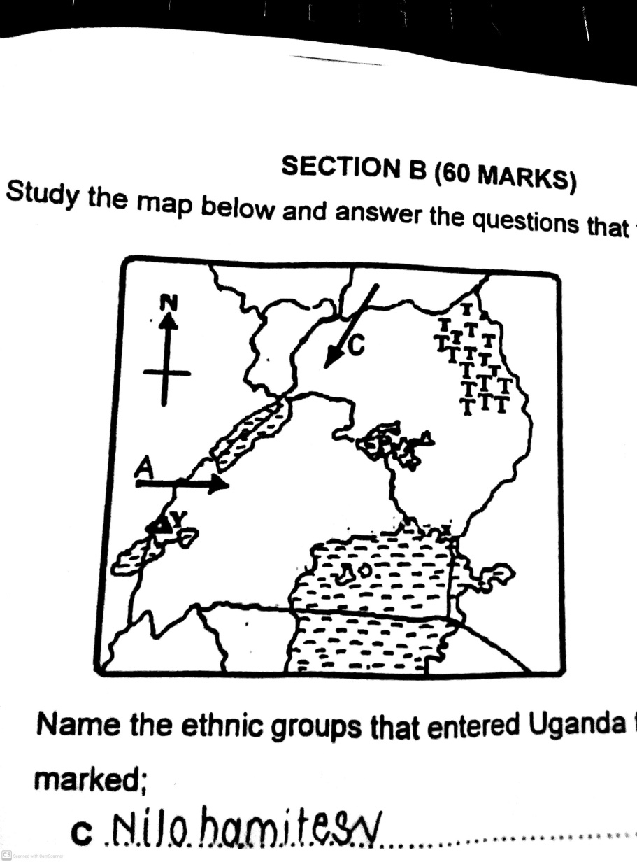

1. Name the ethnic groups that entered Uganda through routes marked;
2. C___________________________________________________________
3. A___________________________________________________________
4. What process led to the formation of the mountain marked Y?

_________________________________________________________________

1. Name the type of climate experienced in the area marked TTT.

_________________________________________________________________

1. a) State any two causes of climate change in East African countries.

i)__________________________________________________________________

ii)__________________________________________________________________

b) Give two ways of controlling climate change in an area.

i)__________________________________________________________________

ii)__________________________________________________________________

1. a) Apart from colonialists, mention two other groups of foreigners that came to Africa.

i)__________________________________________________________________

ii)__________________________________________________________________

b) Give any two reasons why the British colonialists used indirect rule in Uganda.

i)__________________________________________________________________

ii)__________________________________________________________________

1. Match the types of transport in list A to the means of transport in .

|  |  |
| --- | --- |
| **A: Type of transport** | **B: Means of transport** |
| Road transport | Train |
| Railway transport | Helicopter |
| Water transport | Lorry |
| Air transport | Ferry |

1. Road transport____________________________________________________
2. Railway transport___________________________________________________
3. Water transport____________________________________________________
4. Air transport____________________________________________________
5. a) Give any two contributions made by the Bachwezi in Uganda.

i)__________________________________________________________________

ii)__________________________________________________________________

b) State any two factors that led to the collapse of the Chwezi Empire.

i)__________________________________________________________________

ii)__________________________________________________________________

1. Study the map below and answer the questions that follow.

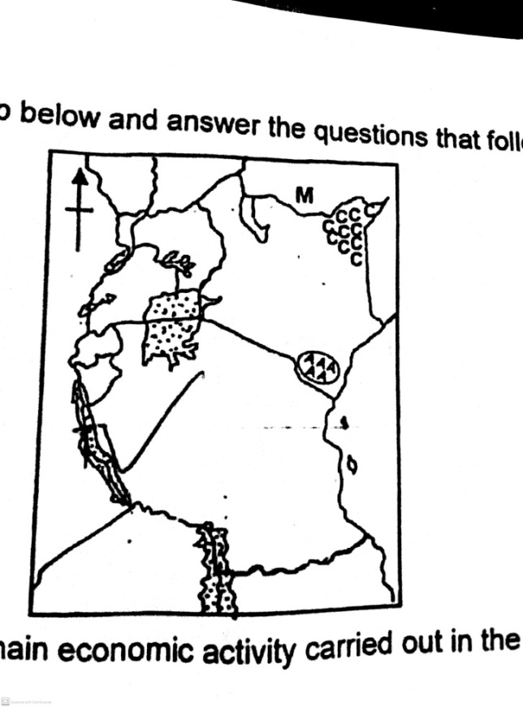

1. Name the main economic activity carried out in the area marked CCC.

________________________________________________________________

1. How did the country marked M become landlocked?

________________________________________________________________

1. Name the game park in the area marked AAA.

________________________________________________________________

1. **Use letter T to indicate Lake Tanganyika on the map above.**
2. a) Give any two factors that have led to the development of the mining industry in South Africa.

i)__________________________________________________________________

ii)__________________________________________________________________

b) Mention any one benefit of mining to South Africa.

___________________________________________________________________

c) Which mineral is mined from the Witwatersrand in South Africa?

_________________________________________________________________

1. a) Give any two examples of human rights.

i)__________________________________________________________________

ii)__________________________________________________________________

b) Mention two ways human rights are violated in Uganda today.

i)__________________________________________________________________

ii)__________________________________________________________________

1. a) Which organization sent the early Missionaries to Uganda?

___________________________________________________________________

b) Why did the Missionaries come to Uganda?

__________________________________________________________________

c) State any two contributions made by the Missionaries in Uganda.

i)__________________________________________________________________

ii)__________________________________________________________________

1. a) What is meant by the term culture?

___________________________________________________________________

___________________________________________________________________

b) State any two cultural activities carried out by young people in Uganda.

i)__________________________________________________________________

ii)__________________________________________________________________

c) Give any one importance of culture to young children.

___________________________________________________________________

**For each of the questions 51 to 55, answer EITHER Christianity OR Islam but not both in a number. No marks will be awarded to a candidate who attempts both alternatives in the same number.**

1. **Either:** a) What term refers to one’s strong belief in God?

___________________________________________________________________

b) Give any two reasons why it is important to believe in God in our daily life.

i)__________________________________________________________________

ii)__________________________________________________________________

c) Give any one practice that can help a Christian to develop their belief in God.

___________________________________________________________________

**OR:** a) What term refers to one’s strong belief in Allah?

___________________________________________________________________

b) Give any two reasons why it is important to believe in Allah in our daily life.

i)__________________________________________________________________

ii)__________________________________________________________________

c) Give any one practice that can help a Muslim to develop their belief in Allah.

___________________________________________________________________

1. **Either:** a) Name the two main parts of the Holy Bible.

i)__________________________________________________________________

ii)__________________________________________________________________

b) Give any two ways of showing respect for the Bible.

i)__________________________________________________________________

ii)__________________________________________________________________

**OR:** a) Name any two prophets who received Holy Books in Islam.

i)__________________________________________________________________

ii)__________________________________________________________________

b) Give any two ways of showing respect for the Quran.

i)__________________________________________________________________

ii)__________________________________________________________________

1. **Either:** a) Give any two miracles performed by Jesus Christ.

i)__________________________________________________________________

ii)__________________________________________________________________

b) Name any two examples of Jesus’ Apostles.

i)__________________________________________________________________

ii)__________________________________________________________________

**OR:** a) Give any two miracles performed by Prophet Muhammad.

i)__________________________________________________________________

ii)__________________________________________________________________

b) Name any two examples of Prophet Muhammad’s Caliphs

i)__________________________________________________________________

ii)__________________________________________________________________

1. **Either:** a) As a Christian child, give any two ways you can help the needy people.

i)__________________________________________________________________

ii)__________________________________________________________________

b) Name any two needy groups of people.

i)__________________________________________________________________

ii)__________________________________________________________________

**OR:** a) As a Muslim child, give any two ways you can help the needy people.

i)__________________________________________________________________

ii)__________________________________________________________________

b) Name any two needy groups of people.

i)__________________________________________________________________

ii)__________________________________________________________________

1. **Either:** a) In how many days did God create the whole world?

___________________________________________________________________

b) State any two reasons why God created man.

i)__________________________________________________________________

ii)__________________________________________________________________

c) How did man disobey God in the Garden of Eden?

___________________________________________________________________

**OR:** a) In how many days did Allah create the whole world?

___________________________________________________________________

b) State any two reasons why Allah created man.

i)__________________________________________________________________

ii)__________________________________________________________________

c) How did man disobey Allah in the Garden of Eden?

___________________________________________________________________

**END**